Project Report On A Cloud Native Microservice System for Ticket Booking

Done By

Tong Xing , Yuqing Zhou ,Yuchen Luo and Jie Ma

Software College of Beijing Jiaotong University

Architecture&Design Pattern:
The project uses MVC architecture.It consists of three parts：
Model: Responsible for storing the central data of the system.
View: Display information to the user.
Controller: Processing information input by the users. It is responsible for reading data from the view, controlling user input, and sending data to the model. It is the part of the application that handles user interaction. Responsible for managing interactive control with users.

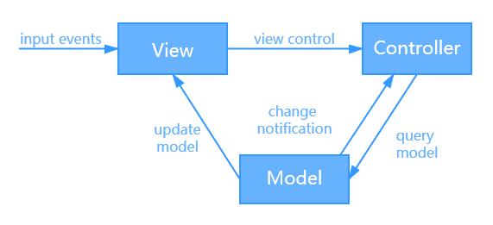
Figure1 - MVC architecture

The booking system contains 3 webservices:
- User microservice: Client can add and delete account using the service.
- Ticket order microservice: All tickets are numbered individually. Existing users can place orders upon a specific ticket upon its availability.
- Payment microservice: Clients make payment upon their order.
Gateway Routing pattern：This pattern route requests to multiple services using a single endpoint.

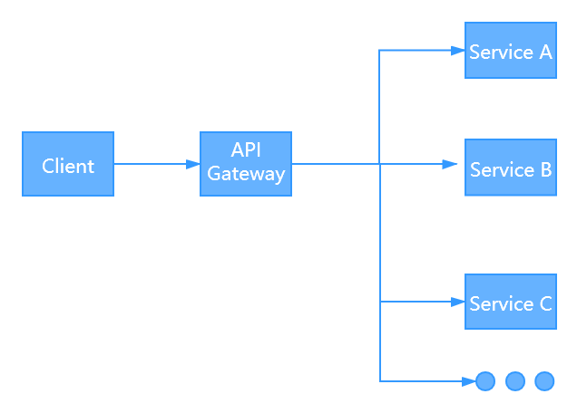
Figure2 - Gateway Routing pattern

Deployment Guide:
First, we Generate certificate and configure local machine and configured for HTTPS
Then, add each project such as gateway/orders/payment/user to docker support
After that, check the dockerfile of each project
Then, add orchestrator support of each project
Finally, run the docker-compose

Testing Results:
User microservice：
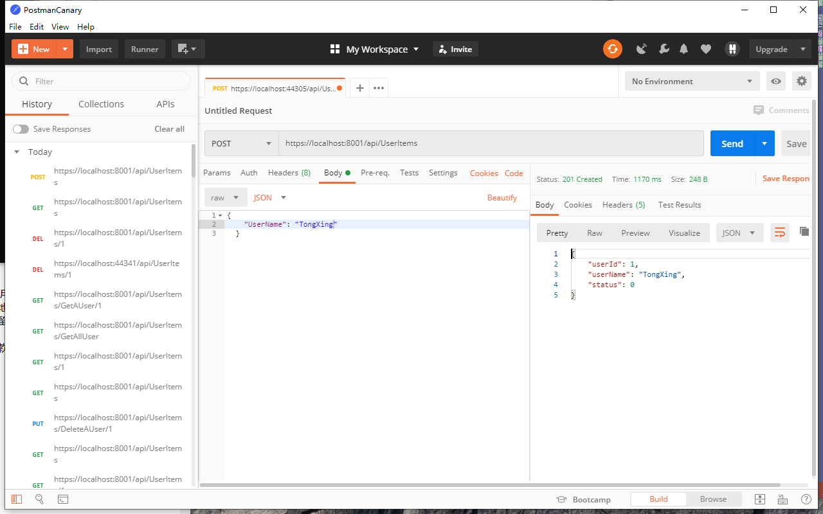
Figure2 - add users
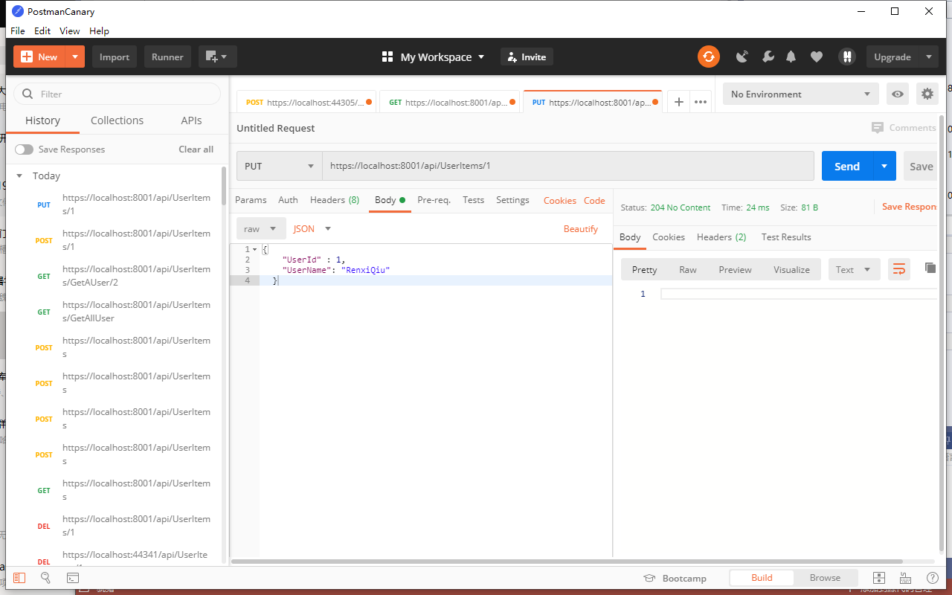
Figure2 - modify user information
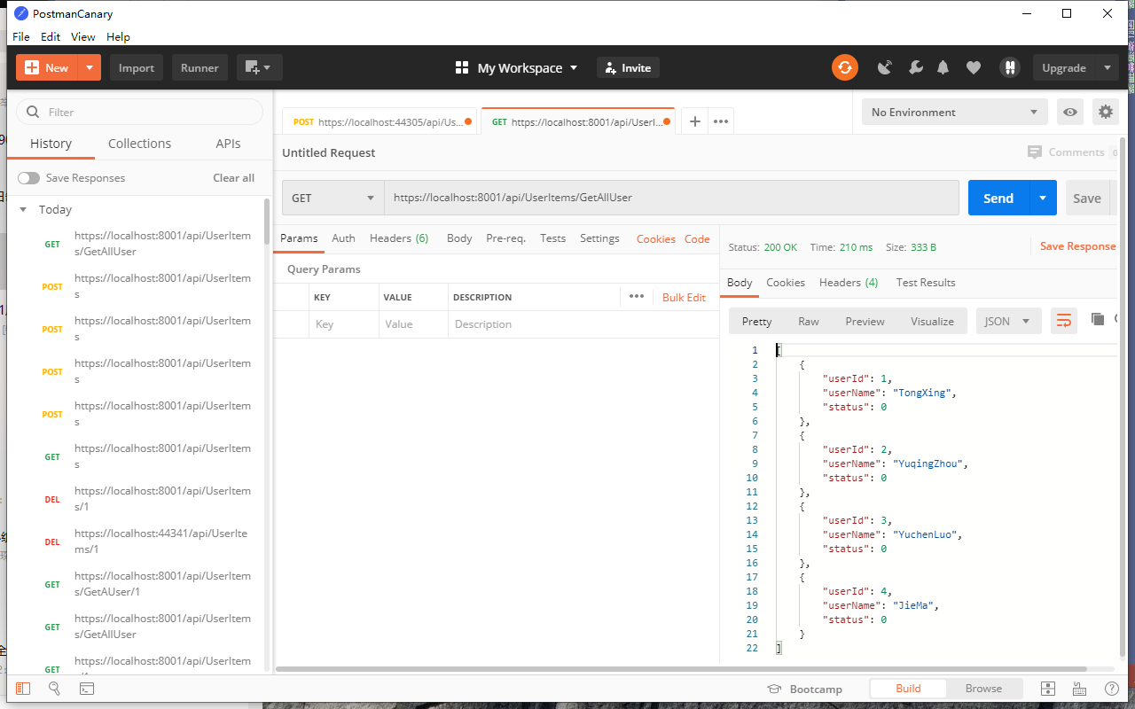
Figure2 - view all users
Ticket order microservice:
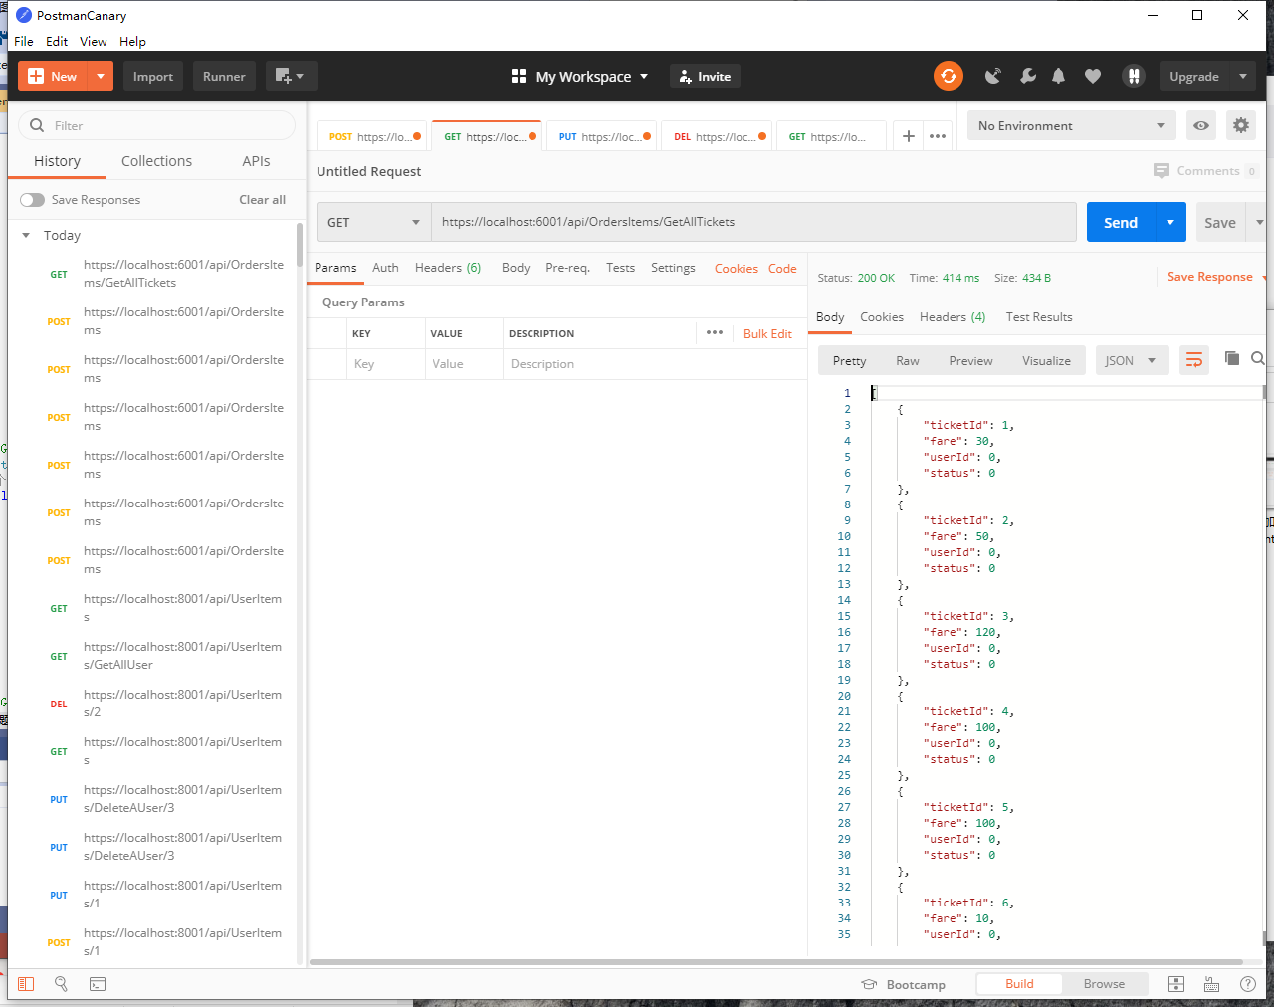
Figure2 - view all tickets
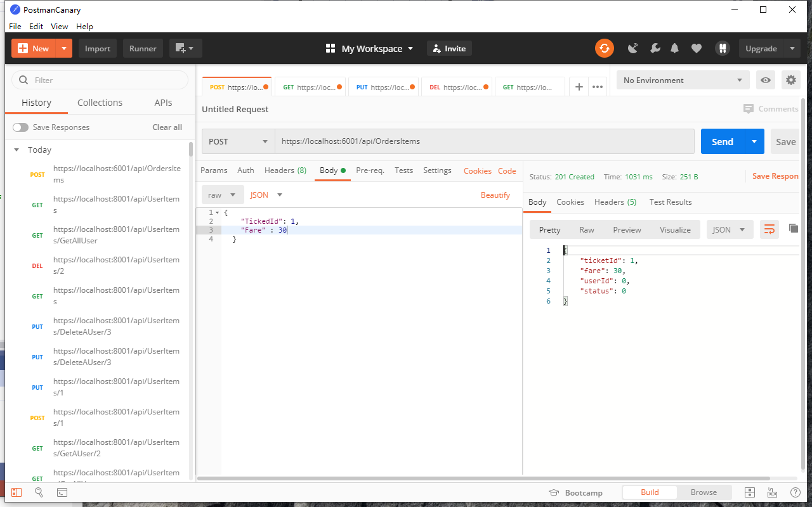
Figure2 - add orders
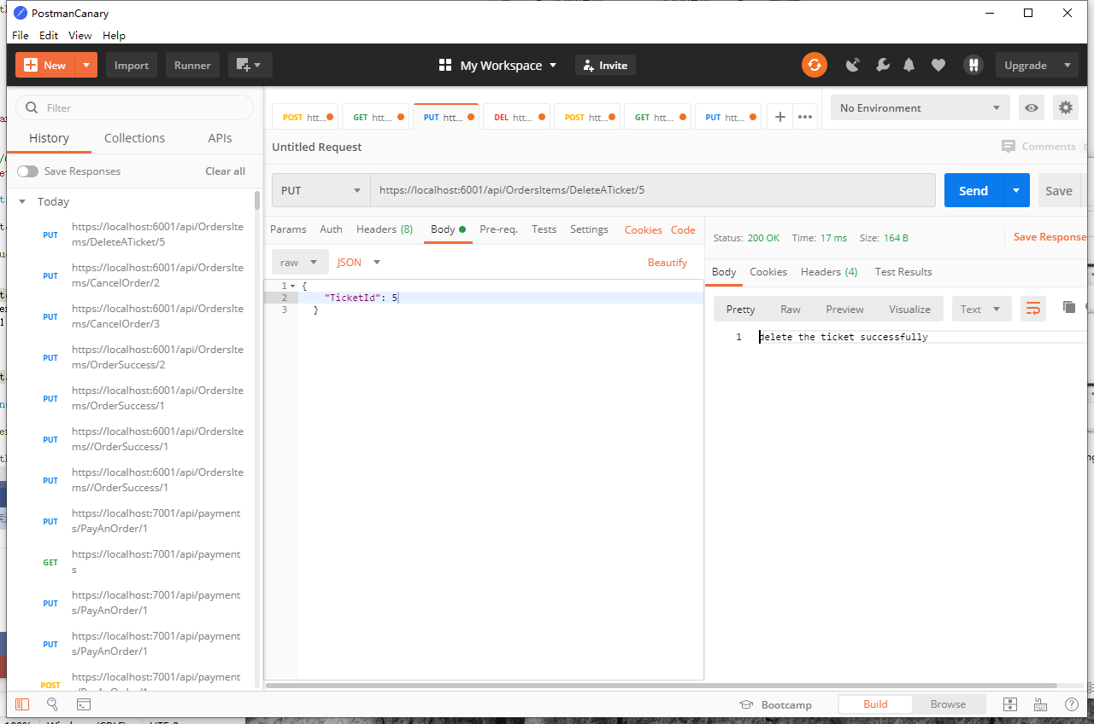
Figure2 - delete tickets

Payment microservice:
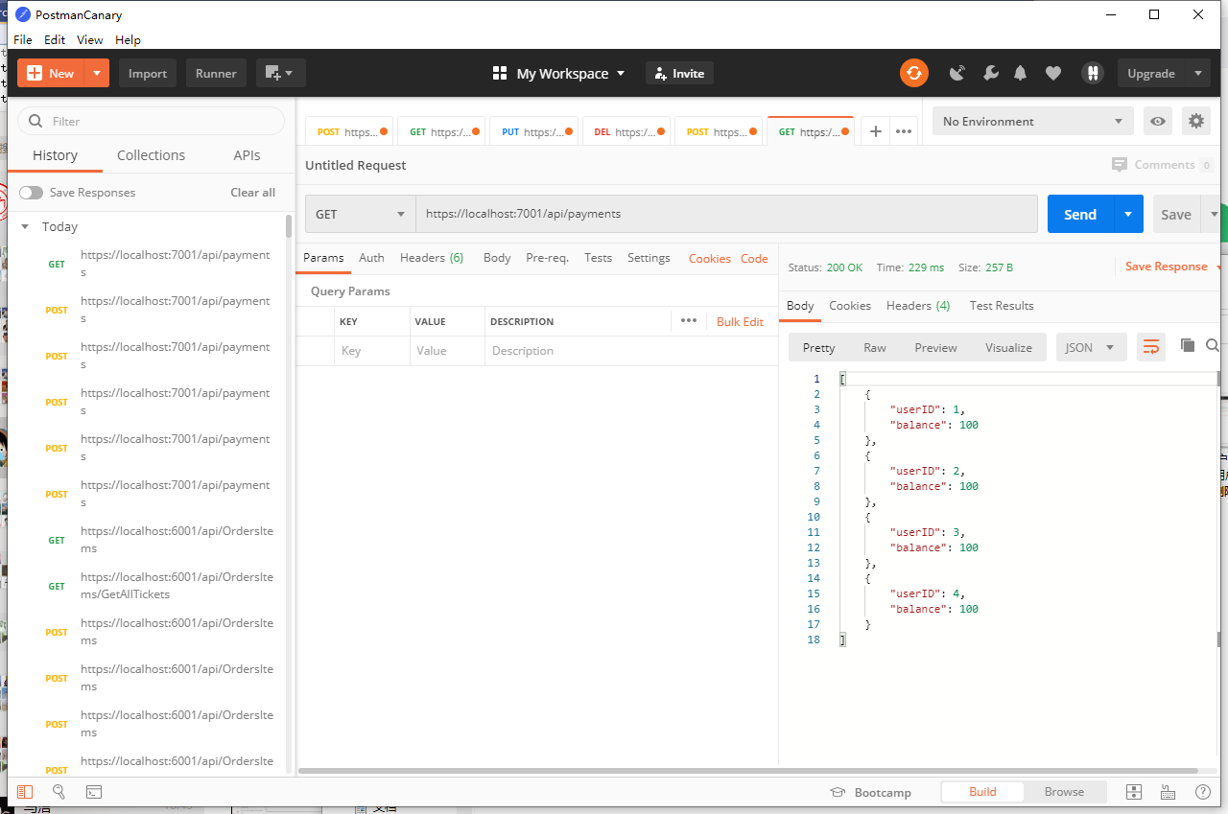
Figure2 - view all payments
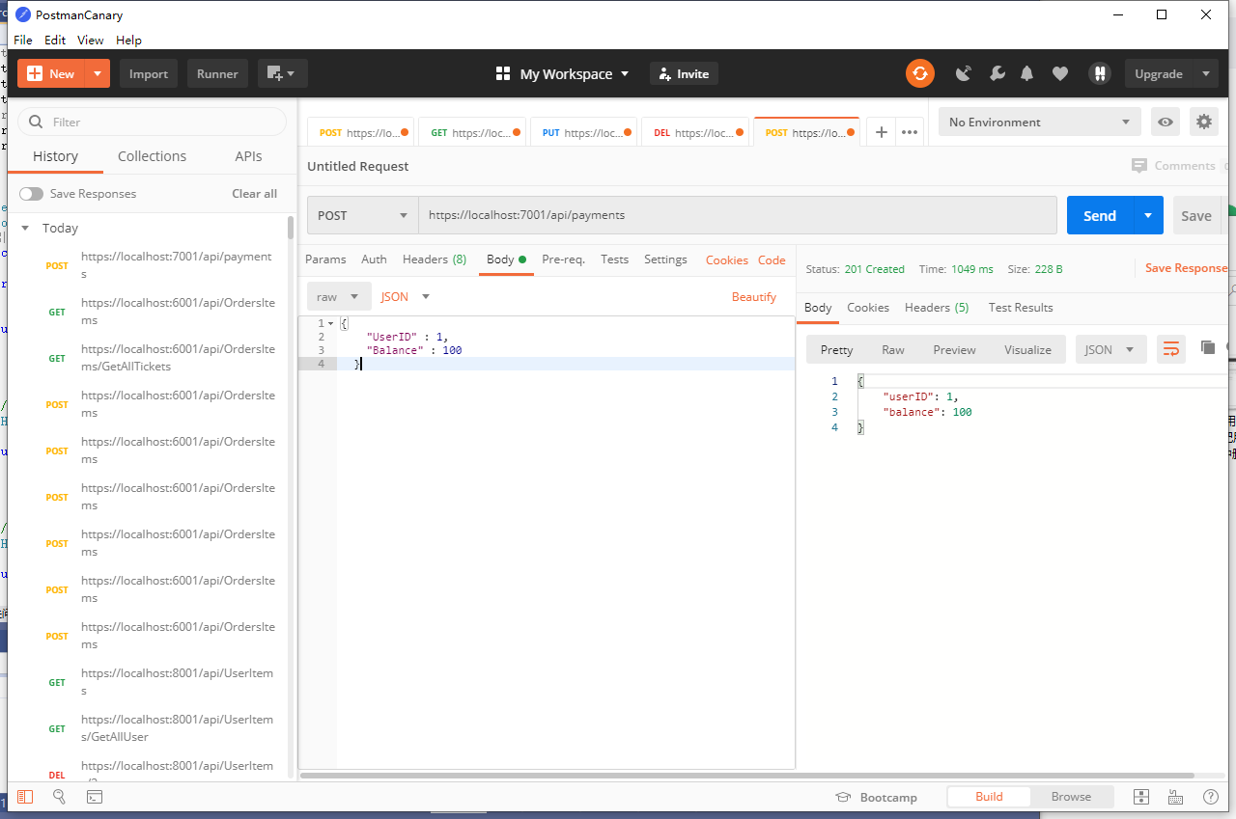
Figure2 - add payments
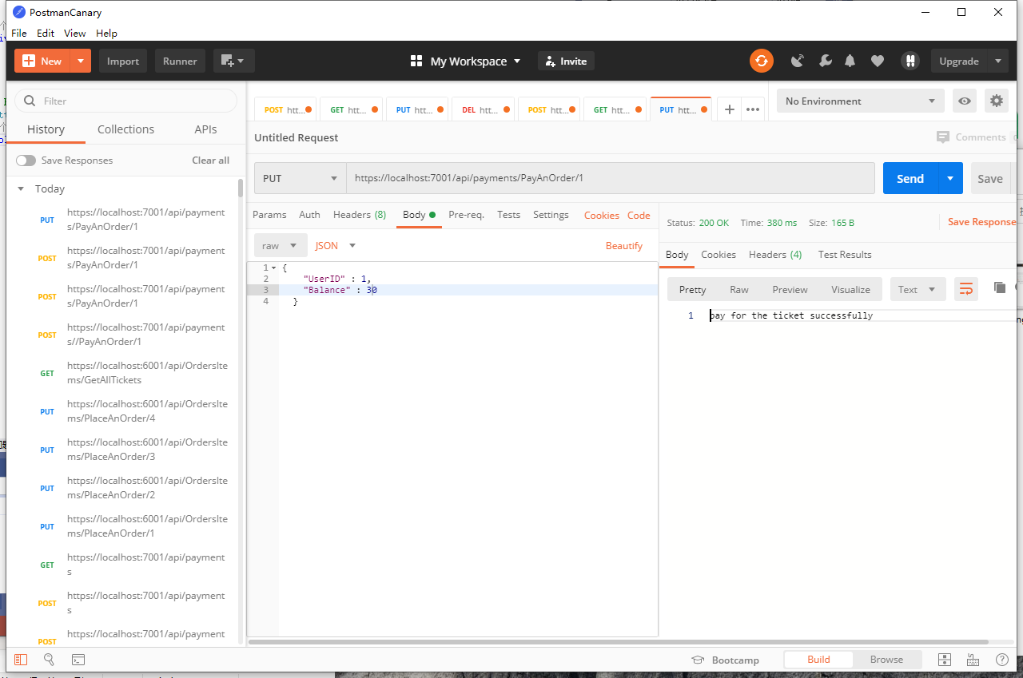
Figure2 - Successful payment
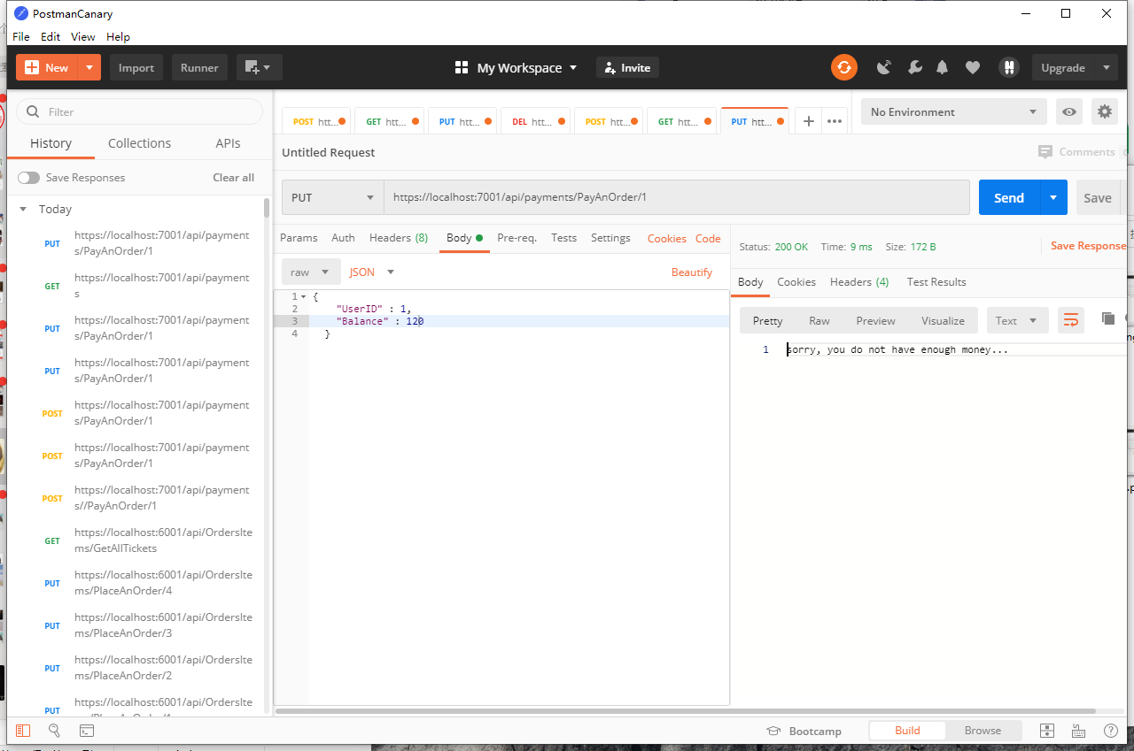
Figure2 - Insufficient balance, payment failed

The Link To The Source Code:
https://github.com/215619461/Ticket-Booking-Assignment

